AUM Amriteswaryai Namah

Assignment 2 – **Mininet Installation and Basic Commands**

* Download and install Oracle Virtual box on your laptop, then install Ubuntu 20.04 version.
  + Oracle virtual box installation instructions for Windows 11 (Linux users follow a different video)
    - <https://www.youtube.com/watch?v=b866-7Y_0KQ> for ver 6.1.26 you may go for ver 7 as well.
    - In the next step, Don’t go for the atest version of Ubuntu as mininet installation may give more trouble.
  + Ubuntu downloads <https://releases.ubuntu.com/20.04/ubuntu-20.04.6-live-server-amd64.iso.torrent?_ga=2.65420518.939786949.1697705261-938358771.1693893225> for LTS
  + <https://releases.ubuntu.com/20.04/ubuntu-20.04.6-desktop-amd64.iso.torrent?_ga=2.89986131.939786949.1697705261-938358771.1693893225> for Desktop
  + Enable Network on your Virtualbox by selecting settings of VM and then go to Network option, and select the right Adapter (in my case Adapter 2)
  + Enable Copy and Paste Option on Virtualbox by doing what is shown in the screenshot
  + 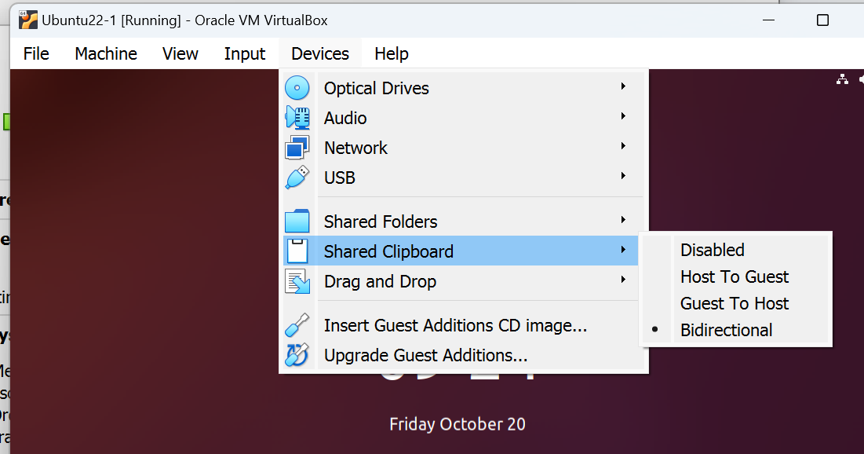
  + You may also enable the option to increase the window size for Virtualbox
    - <https://www.youtube.com/watch?v=hseQds2TOIw>
* Mininet download link is: <http://mininet.org/download/>

Select Mininet installation **option2 or option 3**  Option 1 not recommended

Steps involved are also mentioned in the video

* **For Submission**

Start Mininet and run the basic commands as mentioned in the slide and answer the following Questions:

1. How do I open a Xterm on a host?

Xterm h1 h2

1. How do I get to know all the nodes in the topology?

>> nodes

1. How do I run a command ‘ps -aef’ on specific host h2?

>> ps -aef #in terminal h2

It will print all the processes running on host h2

1. How to run an example Python program on a specific host h1?

Create from inside mininet

Run it from h1 using python my_script.py

1. How do I start a web server on a host and access the index page from another host?

Python3 -m http.server 8080

Wget https://10.0.0.1x

1. How do I get the IP address corresponding to a host?
2. How do I find out all the interface for a switch?
3. What does the command iperf do?
4. Try out linear, Single topology with different number of nodes and switches
5. Create a topology with 4 hosts and 2 switches as follows and ping all the nodes. (Code should be submitted) You may use the following url for Python based mininet APIs <http://mininet.org/api/classmininet_1_1net_1_1Mininet.html>

